Our Understanding of Immune Issues Is Evolving: Here Are 5 Reasons Why
June 14, 2024
Bruce Spiess, MD
News
Article
Recent medical advances include RNA vaccine technology, enhanced understanding of immune dysregulation, improved inter-specialty communication, deeper insights into inflammation, and recognition of biological complexity.
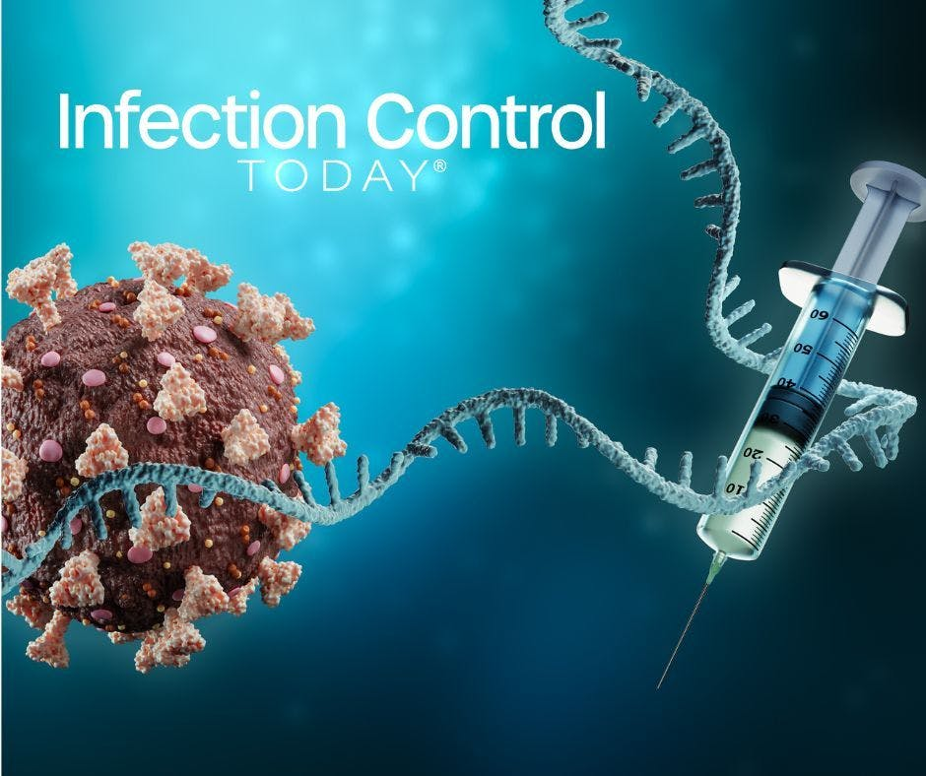
Coronavirus or SARS-CoV-2 virus cell with messenger RNA (mRNA) and syringe on blue background.
(Adobe Stock 404350586 by Matthieu)The world of medicine has changed in the past half a decade. One evolving revolution is the new technology in RNA-mediated vaccines. Scientists conceived, created, tested, and delivered the COVID-19 vaccine at record speed and are now developing and testing RNA vaccines for HIV and malaria. The deep understanding of immune dysregulation as an underlying self-destructive cause of death in COVID-19 has translated to a new understanding of septic shock, adult respiratory disease syndrome, and many long-term indolent chronic diseases such as diabetes and cardiovascular disease.
Our collective understanding of immune issues is what has changed the most. This new understanding offers immense promise as we look to eradicate diseases, solve chronic health care issues, and even tailor medicine to fit each patient's innate biological complexity. Researchers' ability to get into the minds of other experts and combine thinking with a new focus should allow for many advances. Here are five reasons our understanding of immune issues is changing and what it means for health care.
- Messenger RNA Has Changed Vaccines: Vaccines operated predictably for generations. Protein-based vaccines contain small amounts of a virus (the antigen). The body sees the antigen as an invader and then hunts it down. If the virus appears down the road, the body recognizes it and can eradicate it. The mRNA vaccines work differently; the vaccine forces the body to make copies of a protein. The body will then hunt down the invader, also fostering immunity. The breakthrough in vaccine technology via mRNA could accelerate the development and adoption of new vaccines. It has given researchers and scientists many new tools to design the next generation of vaccines and raised hopes about our ability to fight emerging threats. Researchers are already exploring the use of mRNA vaccines to protect against influenza, malaria, tuberculosis, and other viruses and illnesses.
- Medical Specialties Communicate Across Specialties: The pandemic was a global emergency that brought doctors and researchers across medical specialties together to find vaccines and medications. It was a medical army united to end a universal threat. As a result, medicine has evolved over the past 4 years, and there is now unprecedented communication across specialties that was impossible 4 years ago. More breakthroughs will likely occur as specialists work together across boundaries and expertise. The WHO recently called for renewed commitment and cooperation to solve global health challenges.
- Medicine Has a Better Understanding of Inflammation: Due to the pandemic, the medical community has a heightened understanding of inflammation and its role in acute and chronic illness. Inflammation is now one of the most pressing research topics. The Keck School of Medicine at the University of Southern California detailed the mechanisms behind 2 stages of SARS-CoV-2 infection; the virus uses one route the virus takes to invade immune cells, which is associated with severe inflammation. Nature Neuroscience recently published research on blood-brain barrier disruption and sustained systemic inflammation in individuals with long COVID-19: The more we learn about the role of inflammation in acute and chronic illnesses, the more we will find effective treatments and therapies.
- Doctors Have a Greater Appreciation of Biological Complexity: The medical community can no longer live with the idea that if you get an illness or a disease, there is a pill to solve it. Medicine is now looking much more closely at biological complexity; in short, how each body adapts to a complicated world and deals with illness and threats. The pandemic showed that getting back on track is challenging once normalcy goes off the rails. Biological complexity is one reason some could fight off a COVID-19 indication while others were hospitalized. Researchers have already looked at how biological complexity factors into airborne transmission of disease and how biological complexity factors into long-COVID. This focus on biological complexity will help medicine become more tailored.
- The Big Picture: Better Preparation: One of the most striking changes is how our new understanding of immune issues has upended the old paradigm. We are accustomed to influenza and the common cold and grew up believing that if we were immunized and received annual vaccinations, we could beat diseases. We’ve learned we need to be nimbler and can never expect things to stay the same. The good news is that if we focus on immune issues and build on our successes in recent years, we will be better prepared to fight existing scourges and prepare for new threats.

Reference:
https://www.infectioncontroltoday.com/view/our-understanding-of-immune-issues-is-evolving-here-are-5-reasons-why?utm_source=www.infectioncontroltoday.com&utm_medium=relatedContent

